

**Department of Biology**

Coker Hall

Campus Box 3280

Chapel Hill, NC 27599-3280 USA

Phone: 919-962-2077

Fax: 919-962-1625

Web: http://bio.unc.edu

**College of Arts & Sciences**

September 8, 2017

Dear Editor,

We are pleased to submit what we think is a unique and important manuscript for possible publication as a *Letter* in **Nature**: *Climate Change Threatens the Biodiversity of the World’s Marine Protected Areas.*

A prevailing paradigm is that MPAs and other forms of local protection increase the resilience of ecosystems to climate change. We turn the question on its head; instead asking how climate change will undermine the progress we’ve made in mitigating local threats to biodiversity. We combine several different global databases (e.g., on MPA coverage, projected global warming and deoxygenation rates, and species thermal distributions) to analyze the extent to which carbon emissions could impact marine life currently protected within MPAs. We describe the dependence of these impacts on our future emissions, latitude, ecoregion, and other contexts.

Our results strongly suggest that without drastic reductions in carbon emissions, ocean warming and oxygen depletion in the 21st century will disrupt the composition and functioning of the ecosystems currently protected within the world’s MPAs. We further offer the novel insight that the spatial distribution of stressors in MPAs are decoupled, thus rearranging MPAs to minimize exposure to one factor could well increase exposure to another.

Given our global lack of progress in reducing emissions, the many threats to marine biodiversity, and the recent withdrawal of the U.S. from the Paris Climate Accord, we believe these findings are more timely than ever.

Thank you for considering our manuscript.

Sincerely,

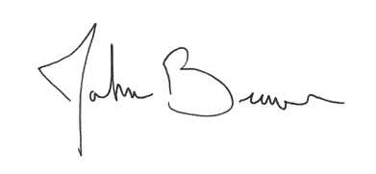

John F. Bruno, PhD

Professor